**OUTREACH SCHOOLS EXAMINATION BOARD**

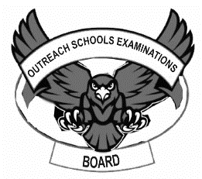 **END OF TERM II EXAMINATION 2024**

**BABY CLASS: (3 – 4 YEARS)**

**LEARNING AREA 5: LANGUAGE DEVELOPMENT II**

**My name is: ………………………………..………………………….**

**My School is: ……………………………..……….…………………..**

**I am in: ………………………………..…………………………………………..**

1. **Match sounds to pictures.**

s

d

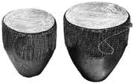

t



p

a

1. 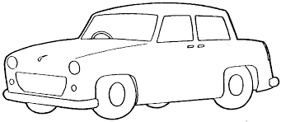**Trace ‘c’ and colour the pictures.**



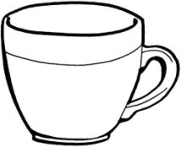

1. **Copy and write.**

|  |  |  |
| --- | --- | --- |
| d | n | i |
| d |  |  |
| p | a | t |
|  |  |  |

1. **Copy and write.**

o o o o o

______________________________________________________________________

_____________________________________________________________________________________________________________________________________________

l l l l l

_____________________________________________________________________________________________________________________________________________________________________________________________________________________

d d d d d

_____________________________________________________________________________________________________________________________________________________________________________________________________________________

**END**